Process
Step | Desc
Take a copy of the v3 prod instance into test
Take a copy of the v2 prod instance into test
Populate the translation tables (users and modules) from the translation spreadsheets / user external ID. | prcLoad_Modules  prcLoad_USers
Extract: from v2 into extract tables | prcExport
Translate: module and user IDs into Load data tables | prcTranslate
Load: Run Import process into v3 instance. | prcLoad → prcImport
Test (execute test plans)
Restore v3 instance to UAT instance (on Macq Telecom server)
UAT (client sign-off):

Implementation

Data required to populate Salt V3.5

The following information is necessary to populate Salt 3.5
Field (v3.5) | Description
User ID
Module ID
Quiz Mark
Quiz Date
Lesson Complete

The following information is required from Salt 2.5
Field (v2.5) | Description
User ID
Module ID
Quiz Mark
Quiz Date
Lesson Complete

The following information is required in order to perform the required translations.
Field (v2.5) | Field (v3.5) | Description
User ID | User ID
Module ID | Module ID

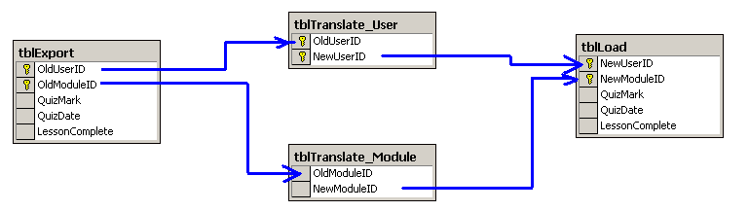
Process
Export from Salt 2.5 into EXPORT table
Export from Salt 3.5 into TRANSLATION_USER
Import from CSV into TRANSLATION_MODULE
Translate EXPORT data into LOAD data.
Load Data

